UCF Configuration Guide
Richard Todd
Test Engineering Services
3.15.2023

Description
This document outlines the necessary steps to configure the UniConsole Framework on startup.

Terminology
Term | Definition
UCF | The UniConsole Framework
Management Console | The tab/text based console that is used to monitor and control all application functionality
Test Executive | The user interface used to automatically sequence all tests and save measurement data to a local database
Go-nogo | A test sequence initiated by the test executive will stop on the first measurement failure

Configuration Settings
The following test executive startup settings can be configured using system variables. These settings are optional.

Management Console GUI interface size and location

Test Executive GUI interface size and location

The initial test mode (Go-nogo)

The manufacturer's name and location of the test station

Test specifications, parameters and limits for each test profile

The number of units to be tested concurrently

Manual UUT serial number verification

System variables
System variables are stored in local or global sqlite databases and are configured using the ‘DB Browser for Sqlite’ application.

Locations
Database Type | Database Location | Platform
Local | ~/ucfroot/opt/<Profile Family Name>/ExtSystemIO.sdb | Linux
 | C:\ucfroot\opt\<Profile Family Name>\ExtSystemIO.sdb | Windows
Global | ~/ucfroot/bin/<Release Name>/IOConfig/BaseSystemIO.sdb | Linux
 | C:\ucfroot\bin\<Release Name>\IOConfig\BaseSystemIO.sdb | Windows

Local database values are unique to a specific profile family and will override values in global databases.

Global database values will be used for all profiles that do not have overriding values in a local database.

User Interface Configuration
The Management Console and Test Executive user interface can be optionally configured using system variables.
- Management Console window size & location
- Test Executive window size & location
- Initial test mode (Go-nogo enable)

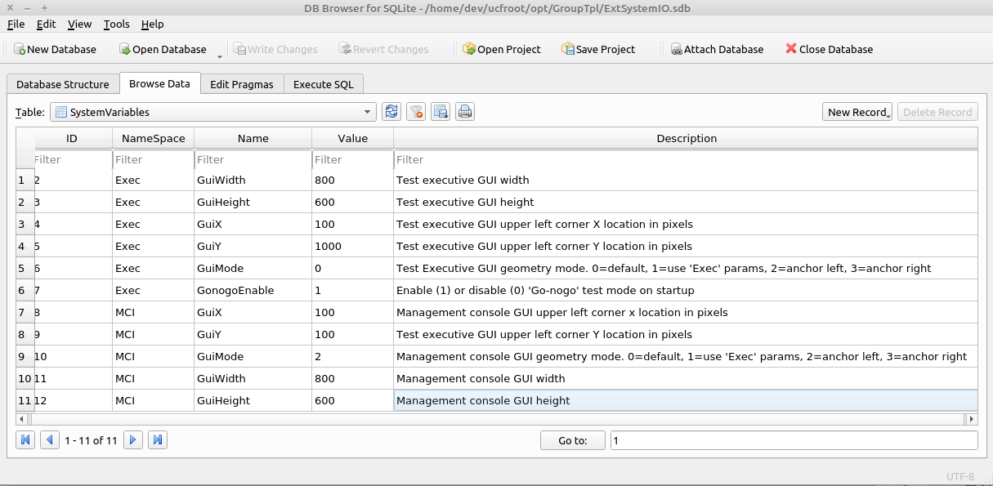

Where
‘Exec::GuiMode’ specifies the display mode of the test executive user interface.
0=default
1=use ‘Exec’ system variables to set geometry
2=anchor left
3=anchor right
‘MCI::GuiMode’ specifies the display mode of the management console user interface.
0=default
1=use ‘Exec’ system variables to set geometry
2=anchor left
3=anchor right
‘Exec::GuiMode’ specifies the execution mode of the test executive on startup.
0=Do not stop on first test failure
1=Stop on first test failure

Test Specification Configuration Process
The test executive is designed to use test limits from a version controlled test specification. Each parameter saved in the database is traceable to
- The test specification used to determine pass/fail status
- The manufacturers name and physical location
- The test station used to save the parameters
Test specification information is stored in local sqlite database and is configured using the ‘DB Browser for Sqlite’ application.

Database Type | Database Location | Platform
Manufacturing ID | /var/lib/ucf/Static.sdb | Linux
 | C:\ucfroot\var\lib\Static.sdb | Windows
Test Specifications | /var/lib/ucf/TestLimits.sdb | Linux
 | C:\ucfroot\var\lib\TestLimits.sdb | Windows

Manufacturing ID
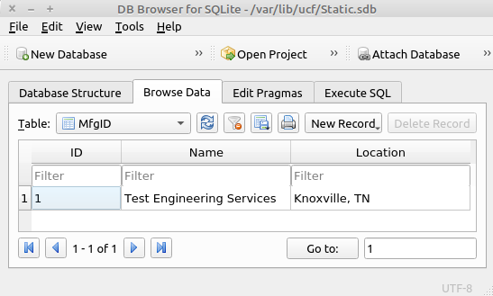

‘Name’ is the name of the manufacturing company.

‘Location’ is the location of the manufacturing company.

Only the first record is used. All additional entries will be ignored.

Test Specification(s)
Any number of test specifications can be set in the TestLimits::TestSpecIndex table.

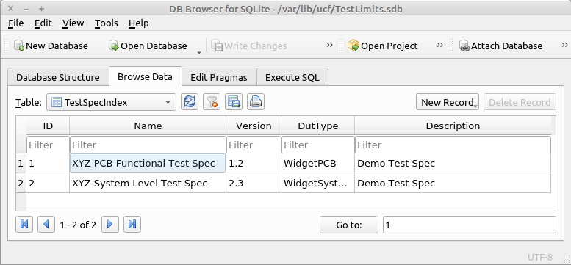

‘ID’ is the numeric identifier used to reference each test specification

‘Name’ is the name of the test specification

‘Version’ is the version of the test specification. Multiple versions can be specified

‘DutType’ is the name/type of UUT to be tested

‘Description’ is a brief description of the test specification

Test Profile Maps(s)
The test profile map table specifies which test specification will be used for each UCF profile.

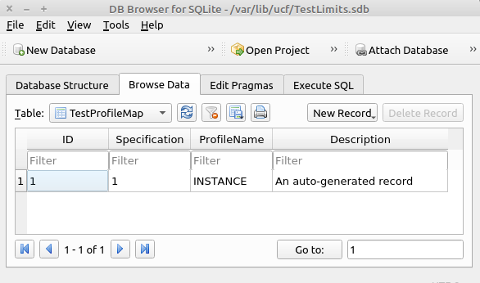

Specification’ corresponds to a test specification ID defined in TestLimits::TestSpecIndex

‘ProfileName’ is the last element in the file path specified when starting the UniConsole framework.

Example UCF startup command:
‘./UniConsole(.exe) -p /home/dev/ucfroot/opt/GroupTpl/INSTANCE‘
Where INSTANCE is the profile name

Test Limits
The test profile map table specifies which test specification will be used for each framework profile.

This table will be automatically populated the first time the test sequence is executed and will use the the
default values specified in the test program. Subsequent test sequence executions will not modify the test limits.

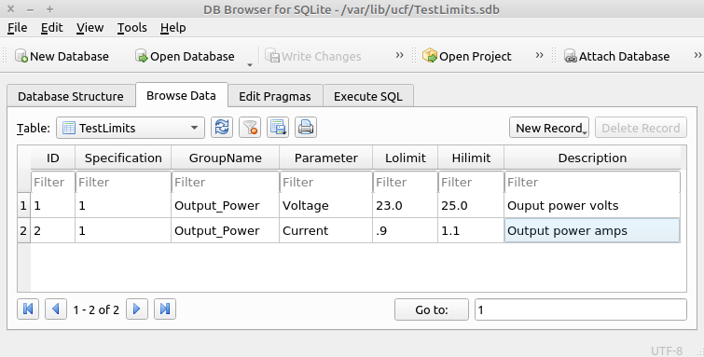

Specification’ corresponds to a test specification ID defined in TestLimits::TestSpecIndex.

‘GroupName' is a category or namespace.

‘Parameter’ is the name of a specific measurement.

‘Lolimit’ is the lower pass/fail threshold. Passing values are >= ‘Lolimit’.

‘Hilimit’ is the upper pass/fail threshold. Passing values are <= 'Hilimit.

Slot Count & Verify Serial Number
The framework is capable of testing 1-16 UUT's concurrently and can require that a serial number be manually entered at the start of a test sequence. These values are optional and will default to ‘1’.

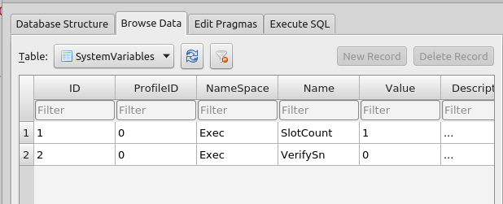

‘ProfileID’ is not used.

‘NameSpace’ = ‘Exec’

‘Name’ = ‘SlotCount’ | ‘VerifySn’

‘SlotCount’ is the number of units to be tested concurrently (1-16).

‘VerifySn’ enable/disables manual input of a serial number at the start of a test sequence.

See section 3.2 for additional system variable information

